1. Download project files
Once we have our environment ready (i.e. npm installed). Let's download the working files. We can do it in two ways:

1.1 GIT repository
In order to download working files, open a console and type:
- shell
git clone https://github.com/mdbootstrap/Vue-Tutorial-Agenda-App.git
COPY CODE

1.2 ZIP file
If for some reason you don't want to use git directly, you can simply download this zip file and extract it.
Info:
The working directory contains multiple folders for each section (getting-started, agenda-app) and inside those are other folders called lesson-x where x is the number of the lesson. Each of the folders contains the final code from a given lesson. In case of facing issues you can always refer to the corresponding lesson folder, check final code and compare with yours to spot the difference.

2. Open project
Open a project in your favorite editor. I use and recommend Visual Studio Code (VSC) from Microsoft
Tip:
If you use VSC I strongly suggest installing the Vetur extension which will add useful features to VSC like a syntax highlighter and .vue file recognition.
Installation:
Open VSC, choose View > Extensions from the menu (or hit ctrl + shift + x). Then search for Vetur in a search bar and click on the Install button next to it.
In order to open a project using VSC:
- Open VSC
- File > Open Folder
- Navigate to getting-started/start-here folder
- Click on Select Folder
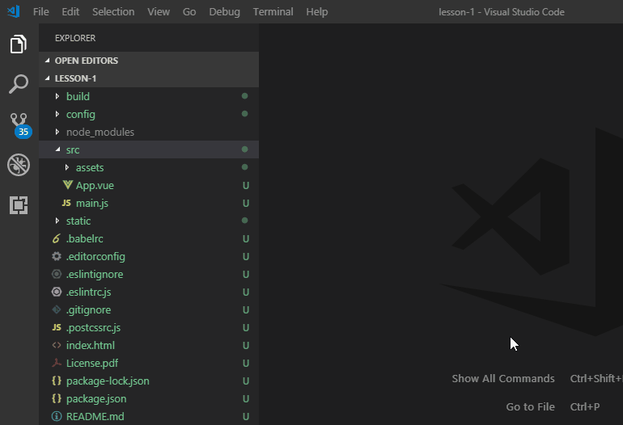

3. Start project
In order to start a project we will use Node Package Manager (npm). Make sure you have npm installed in order to verify that you can open a default terminal/command line:
- Open Command line (below instruction how to open it for Windows, MacOS and Linux)
  - WINDOWS
  - MACOS
  - LINUX

How to run command line?

Keyboard shortcut:
On your keyboard press: + R . You will see Run windows. Type cmd and click OK or press Enter
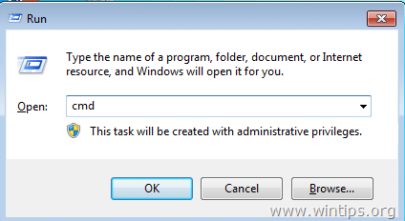
You will see a screen like below:
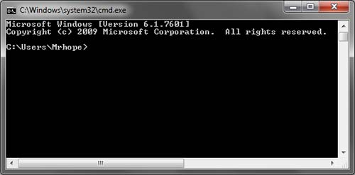
That's it. You can now use a command line, however, please keep in mind that Windows Command Line is - frankly speaking - a crappy tool. That's why we strongly encourage you to use some alternative such as GitBash (installation guide here). It has more Unix-like commands that are more user-friendly than built in windows commands.

- Type npm -v and press Enter
If you can see the version of npm we can start the project (go to the next step). Otherwise you have to install npm first. Here you can find the guide on how to do it.
- Navigate to the project location using the command cd (the location on your computer will be different):
cd C:\Users\Dawid\vuetutorial\getting-started\start-here>
- Install dependencies using the npm install command
- Start the project using the npm start command
- Open a web browser and navigate to http://localhost:8080

4. Hello World!
- Open the src/App.vue file.
- Type <p>Hello Vue World</p> between <template></template>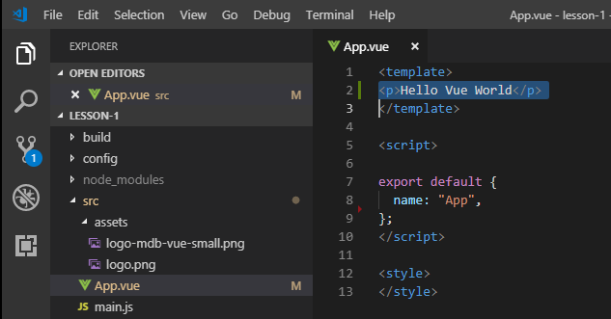
- Check the result in a browser: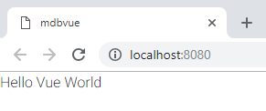
Voila! Our application is running. That was easy, wasn't it? Now let's have a closer look at our project structure to understand how Vue project works.

5. Project structure
Let's have a look at the files within our project. There are multiple folders and files and each is responsible for a variety of functionalities, however you don't have to know all of them, for now, I will introduce you to the key files and directories within our project.
Let's have a look at the project tree:
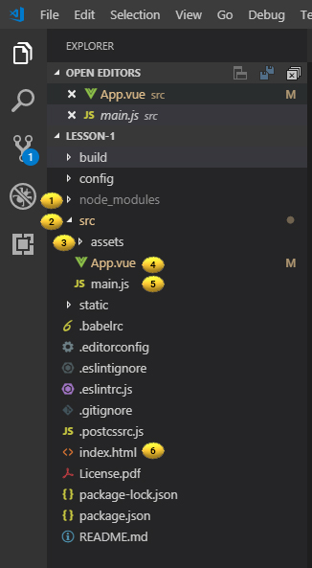
- The node_modules directory is where all of the libraries we need to build Vue are stored.
- In the src directory, is placed the source code of your application.
- In the assets ddirectory, is placed the any static assets such as images or icons.
- The App.vue file is the root component that all the other components are nested within.
- The main.js file is what renders our App.vue component (and everything nested within it) and mounts it to the DOM.
- index.html is the main file of our app.
If we peek inside our index.html file, we can see there’s a div with the id of "app", which means this is where our App will be mounted.
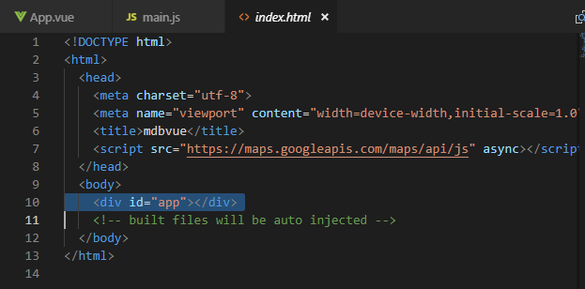

6. Single file components
Let's have a look at App.vue file. This is a so-called single file component.
As you may notice the file consists of three parts:
- Template
- Scripts
- Styles
As you can easily deduce, the template part is responsible for a view of our component, the script contains the configuration of the component as well as the required functions, while styles contain the dedicated CSS styles that are applied to our component.
In the next lesson, we will learn how to build and use sample components.
Important!
I am very happy that you reached this far. I would like to thank you and ask you for a small favor. Please rate this lesson using he stars below.
Your feedback is very important to us! Once you vote (it's just a single click!) there will be an optional form which let you leave comment to us. Please let us know what you liked and what you didn't like to help us make later tutorials better and better!
It would be awesome if after each lesson you would be so kind and gie a click to rate every lesson. I would appreciate that! Thanks!
As we noticed in a previous lesson our App.vue component consisted of three parts:
- Template
- Script
- Style
In this lesson, we will take a closer look at each of these.
First, please replace the content of App.vue file with the following content
- Vue
<template>
<div class="app">
<h1>This is your first component in Vue</h1>
<h3>{{ message }}</h3>
</div>
</template>

<script>
export default {
name: "App",
data: () => ({
message: "Powered by MDB!"
})
};
</script>

<style>
.app {
margin: 0 auto;
font-family: sans-serif;
background-color: #ccf7e2;
padding: 10px;
border-radius: 5px;
max-width: 500px;
}
</style>
COPY CODE
Save the file and preview. You should get something like this
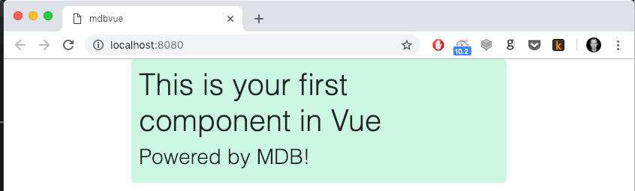

1. Template

1.1 Single root element
This part of the component is responsible for rendering its view. As you notice we use HTML inside. One important thing to remember is that the content inside should contain only a single root element. In other words - it should always be wrapped with some placeholder (i.e. ).
If we try to render two tags next to each other, the compiler will complain.
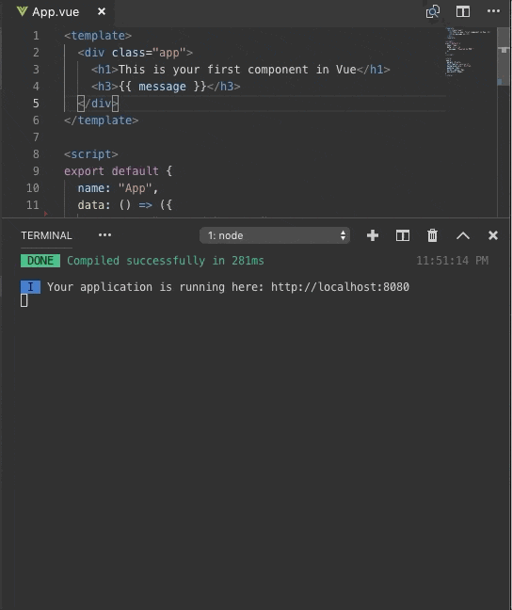

1.2 Mustache string interpolation
The other interesting and possibly new to you element is the heading.
This is so-called "Mustache" syntax (double curly braces). This text interpolation is the most basic form of data binding. As you may notice, the variable is dynamically replaced by the string assigned to the variable inside the function within script part.
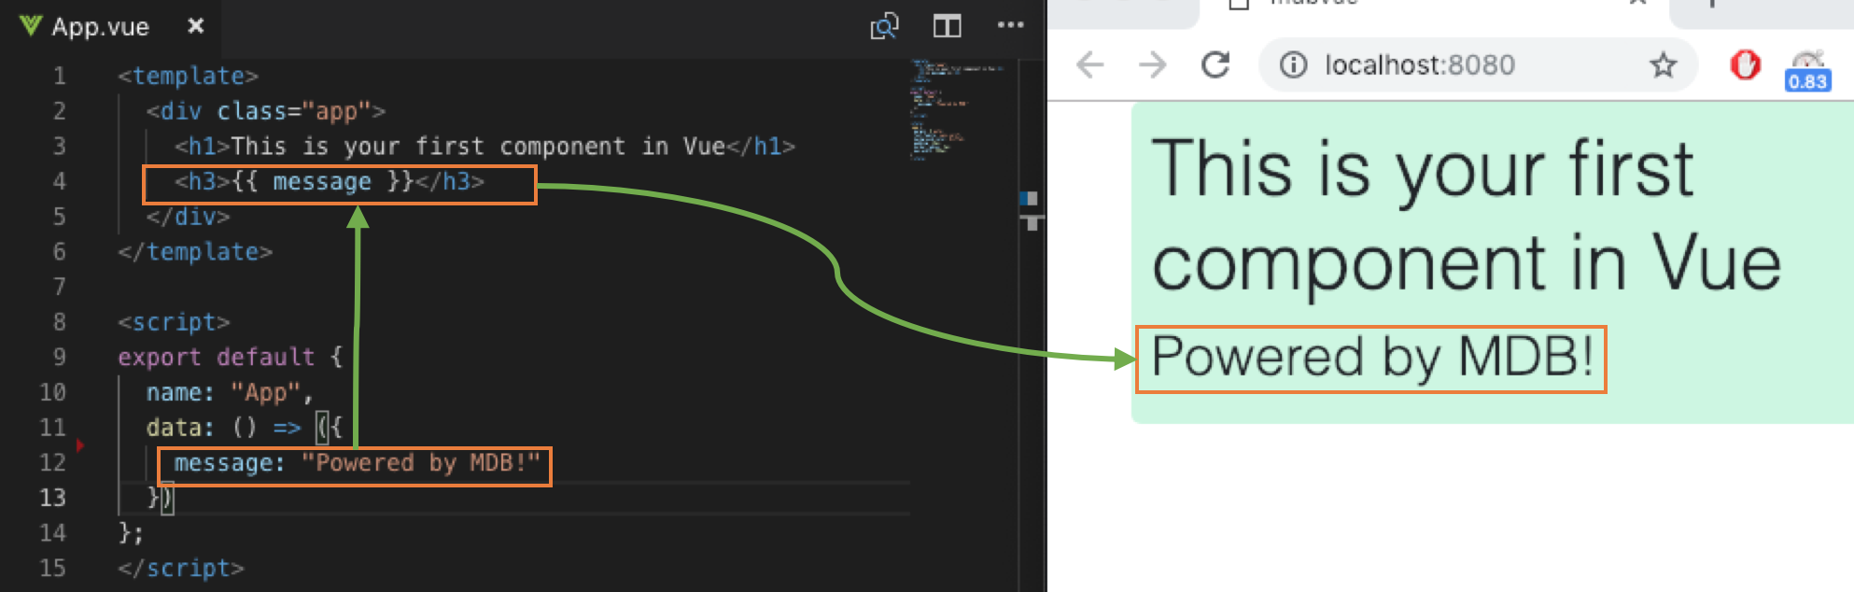

Using JavaScript Expressions
So far we’ve only been binding to simple property keys in our templates. But Vue.js actually supports the full power of JavaScript expressions inside all data bindings. For example the code below:
- Vue
<ul>
<li>{{ number + 1 }}</li>
<li>Value of ok var is: + {{ ok ? 'true' : 'false' }}</li>
<li>{{ message.split('').reverse().join('') }}</li>
</ul>

[...]

data: () => ({
message: "Powered by MDB!",
number: 5,
ok: true
})
COPY CODE
Runnint the above will result in:
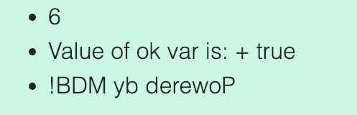

2. Script
This part of the code is important for each component for a few reasons. It's a place where:
- we can export our component (and define its name) so that we can use it in other components
- we have to list external components before we are be able to use them within our component
- we define attributes (variables) their values
- we define JavaScript functions used within a component
We will study the first and second point in details in the next lesson where we will learn how to export and import components within Vue. For now, let's have a closer look at points three and four.

2.1 Attributes
As you already seen in a previous lesson, we can define variables inside the function so we can use them inside our template part:
We can use them as part of our logic, for example:
- Vue - template
<span v-if="visible">Now you see me</span>
COPY CODE
- Vue - script
data: () => ({
message: "Powered by MDB!",
visible: true
})
COPY CODE
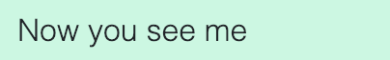
Or as placeholders for our data (which can be directly modified using functions):
- Vue - template
<ol>
<li v-for="todo in todos">{{ todo.text }}</li>
</ol>
COPY CODE
- Vue - script
data: () => ({
todos: [
{ text: "Learn JavaScript" },
{ text: "Learn Vue" },
{ text: "Build something awesome" }
]
})
COPY CODE
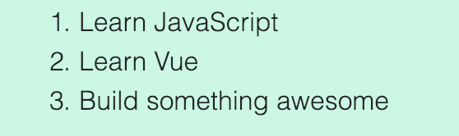

2.2 Functions
As you already know, we can do quite a lot of JS inside template sections using Mustache interpolation. Though, in-template expressions are very convenient, they are meant for simple operations. Putting too much logic in your templates can make them bloated and hard to maintain. For example:
- Vue - template
<li>{{ message.split('').reverse().join('') }}</li>
COPY CODE
At this point, the template is no longer simple and declarative. You have to look at it for a second before realizing that it displays the in reverse. The problem is made worse when you want to include the reversed in your template more than once.
That’s why for any complex logic, you should use functions and return final result.
- Vue (template)
<p>Original message: "{{ message }}"</p>
<p>Computed reversed message: "{{ reversedMessage }}"</p>
COPY CODE
- Vue (script)
export default {
name: "App",
data: () => ({
message: "Powered by MDB!",
}),
computed: {
// a computed getter
reversedMessage: function() {
// `this` points to the vm instance
return this.message
.split("")
.reverse()
.join("");
}
}
};
COPY CODE
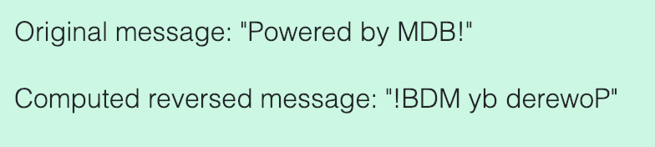
As you can see we can use double culry braces (mustache interpolation) not only to return value of a variable but also to call functions defined withing script part.

3. Styles
Last but not least is our CSS part. This section is quite self-descriptive. It's meant to store all the styles used by the component. What is important is that styles can be scoped.
This means that if you use a style like that below:
- Vue (script)
<style>
div[class*=" col"] {
border: 1px dotted black;
}
</style>
COPY CODE
...this style will be applied to any div within the entire website. It will be global. If you want to narrow its scope to divs within our component only, you can add the option:
- Vue (script)
<style scoped>
...
</style>
Amongst other advantages, Vue gained incredible momentum within the last year thanks to its reactive and composable components. Components are reusable Vue instances with a name. We can use this component as a custom element inside a root.
It’s common for an app to be organized into a tree of nested components:
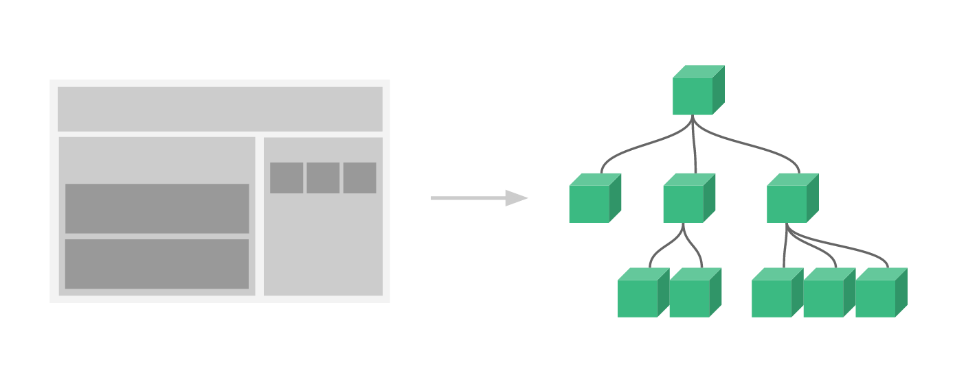
In this lesson, we will learn how to create, use and organize components.

1. Create and export component
- Create a new folder and call it components inside the src folder: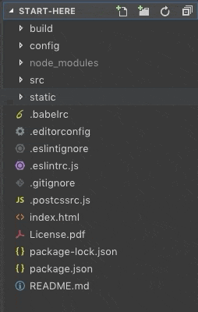
- Create a new file called HelloWorld.vue inside comopnents/ folder: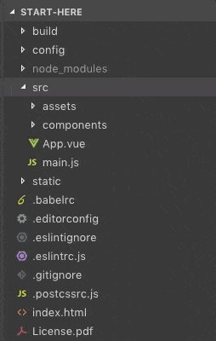
- Open the HelloWorld.vue file and paste the following code into it:
  - Vue
<template>
<div class="hello">
<h3>I am Hello World Component</h3>
</div>
</template>

<script>
export default {
name: "HelloWorld"
};
</script>

<style scoped>
h3 {
font-weight: normal;
padding-top: 20px;
padding-bottom: 30px;
}
</style>
COPY CODE
As you noticed - within our script part we export our component:
- Vue (script)
<script>
export default {
name: "HelloWorld"
};
</script>
COPY CODE
This is the place where we can define the name of our component. Now when our component is ready can use it within our App component.

2. Import component
- Open and replace the content of the App.vue file with the following:
  - Vue
<template>
<div class="app">
<h2>I am App (main component)</h2>
</div>
</template>

<script>
export default {
name: "App"
};
</script>

<style>
.app {
margin: 0 auto;
font-family: sans-serif;
background-color: #ccf7e2;
padding: 10px;
border-radius: 5px;
max-width: 500px;
}
</style>
COPY CODE
In order to use the HelloWorld component we have to first import and define it within thescript part:
- Add an import statement:
  - Vue (script)
<script>
import HelloWorld from "@/components/HelloWorld";

[...]
</script>
COPY CODE
- Within the declaration add to components list:
  - Vue (script)
export default {
name: "App",
components: {
HelloWorld
}
};
COPY CODE
- Now we can use our new component using the tag:
  - Vue (template)
<template>
<div class="app">
<h2>I am App (main component)</h2>
<HelloWorld/>
</div>
</template>
COPY CODE
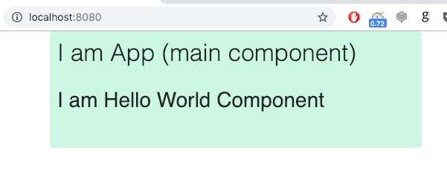
1. App goals and overview
Now when we know the basic concept behind how Vue works let's build a real App! I am going to show you the final result first and then quickly analyze it. After that, I will show you how to build this app from scratch.
So, let's don't waste more time and start working.

2. Run the app
Within the tutorial files you will find a final application code, let's use it to run our app:
- Open a terminal
- Navigate to the agenda-app/final/ folder
- Install the dependencies using npm install
- Run the app using npm start
- See the results in a browser:
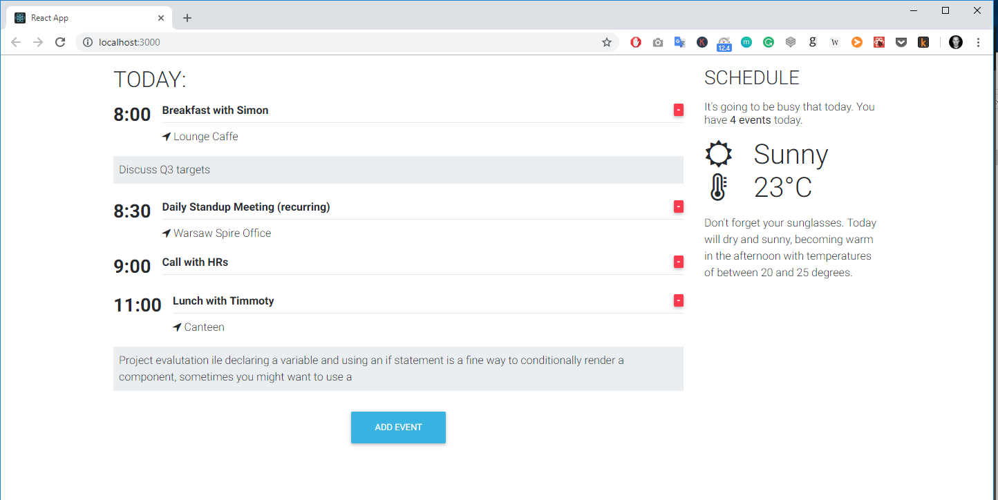
Voila! Our app is running.

3. Test the app
The application which we are about to build is a daily agenda app. It allows us to display a list of events planned for today including time, title, location and description. We can add new Events as well as remove existing ones. The app also displays a weather forecast.
Now take some time to play with the app. Note that whenever you are adding/removing events, the counter in the right column is changing.
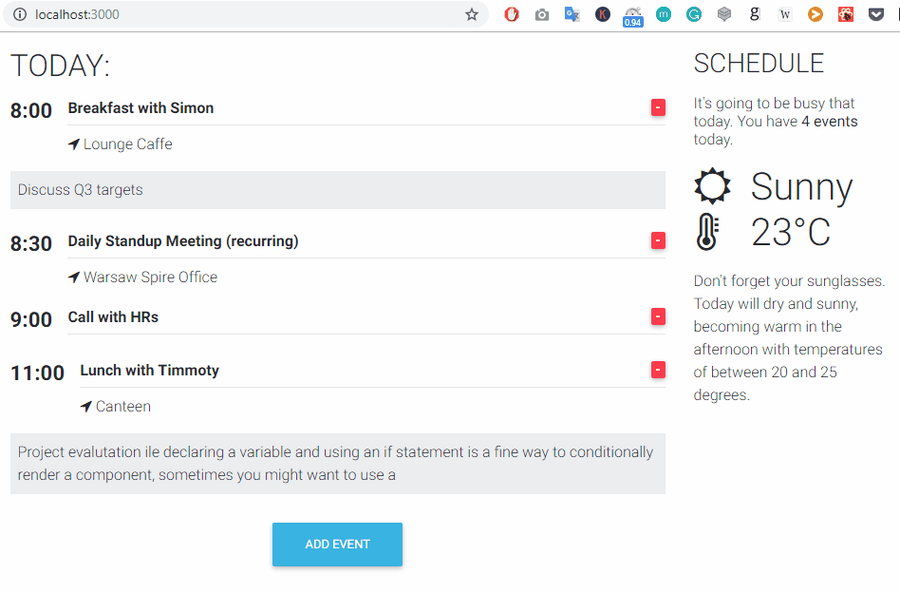

4. Responsiveness
Our application is also responsive by default. Just change the size of the browser to see how it displays on different screen size:
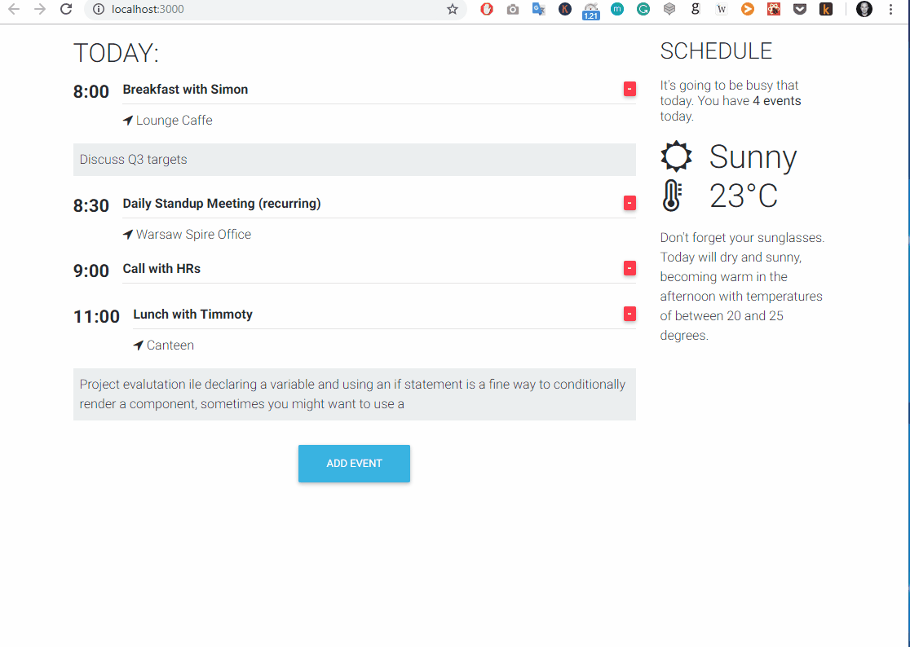
We will start building our app by setting up the two column structure of our app. As you can see in the demo app our app consists of two columns: the first, on the left and wider, which lists all the daily events; and the right hand one - which shows the events counter as well as the weather forecast.
As you also noticed our app will be responsible. This is thanks to Bootstrap 4. In this lesson, we will learn how to use a Bootstrap grid in Vue.
Disclaimer: I will explain the key concepts and basic usage here. If you want to master Bootstrap usage I strongly suggest to finish this course first and come back here.

1. Open the project
In order to start building our project let's open a boilerplate which I have prepared for you in Tutorial files which you downloaded before.
- Open the agenda-app/start-here project in code editor
- Replace the content of the App.vue file with the following code:
  - Vue
<template>
<mdb-container>
<mdb-row>
<mdb-col col="6">Left column</mdb-col>
<mdb-col col="6">Right column</mdb-col>
</mdb-row>
</mdb-container>
</template>

<script>
import { mdbContainer, mdbRow, mdbCol } from "mdbvue";
export default {
name: "App",
components: {
mdbContainer,
mdbRow,
mdbCol
}
};
</script>

<style>
div[class^="col"],
div[class*=" col"] {
border: 1px dotted black;
}
</style>
COPY CODE
What we did:
- Added a container, with a row and two columns inside within
- Imported container, row and column component and registered them inside the
- Added a style to make our grid borders visible inside the

1. The concept of the grid
Currently, our app has two equal-sized columns which are placed next to each other on a large screen. When we resize our browser window they will nest one beneath the other:
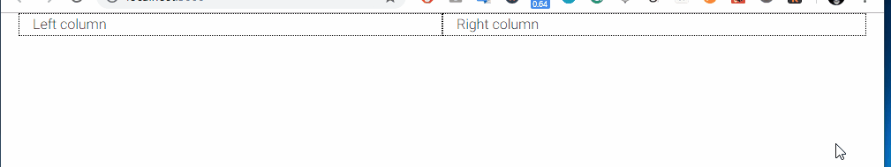
What is the Bootstrap Grid?
In nutshell, it's a mechanism which allows us to create a responsive website. The Bootstrap grid allows us to define rows, and each row consists of up to 12 columns.
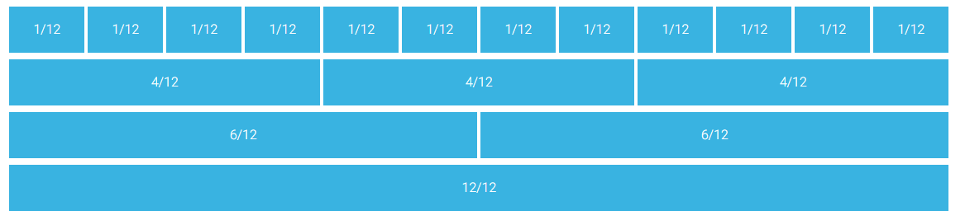
You can either use one column which will be 12 blocks long or use multiple smaller blocks. The only rule is that you cannot exceed more than 12 blocks in a row. The blocks don't have to be equal in size:
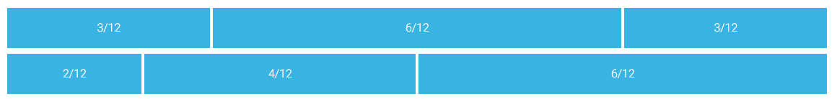
And you can skip some of the columns, as well as align them horizontally:
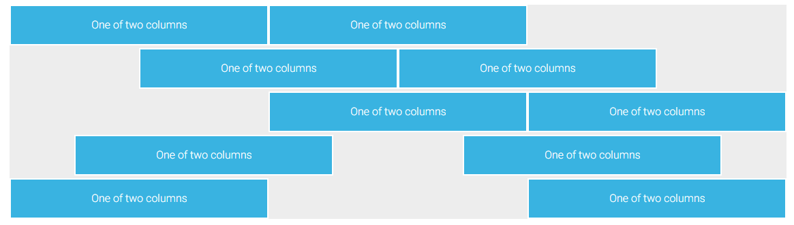
For more advanced usage you can check our docs:

3. Responsive breakpoints
Bootstrap is developed to be mobile first - it uses a handful of media queries to create sensible breakpoints for our layouts. These breakpoints are mostly based on minimum viewport widths and allow you to scale up elements as the viewport changes.
This is one of the most important features - in other words: you can define a different column size for different screen sizes. Bootstrap lists five different screen sizes, extra small (default), small (sm), medium (md), large (lg) and extra large (xl). Each size has a breaking point defined according to the table below:
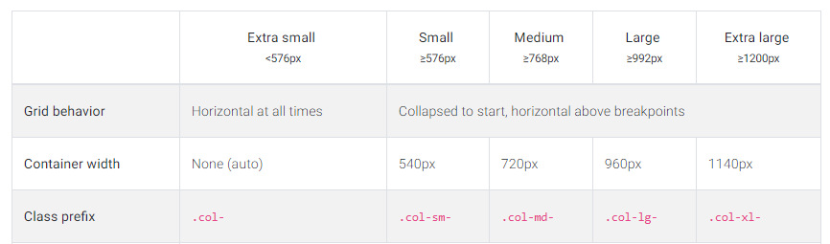Bootstrap responsive breakpoints table
Coming to the conclusion - this super handy tool allows us to create content which will automatically adjust to the screen size. Let's try the following code:
- Vue (template)
<template>
<mdb-container>
<mdb-row>
<mdb-col xl="1" lg="2" md="4" sm="6" size="12">xl=1 lg=2 md=4 sm=6 xs=12</mdb-col>
<mdb-col xl="1" lg="2" md="4" sm="6" size="12">xl=1 lg=2 md=4 sm=6 xs=12</mdb-col>
<mdb-col xl="1" lg="2" md="4" sm="6" size="12">xl=1 lg=2 md=4 sm=6 xs=12</mdb-col>
<mdb-col xl="1" lg="2" md="4" sm="6" size="12">xl=1 lg=2 md=4 sm=6 xs=12</mdb-col>
<mdb-col xl="1" lg="2" md="4" sm="6" size="12">xl=1 lg=2 md=4 sm=6 xs=12</mdb-col>
<mdb-col xl="1" lg="2" md="4" sm="6" size="12">xl=1 lg=2 md=4 sm=6 xs=12</mdb-col>
<mdb-col xl="1" lg="2" md="4" sm="6" size="12">xl=1 lg=2 md=4 sm=6 xs=12</mdb-col>
<mdb-col xl="1" lg="2" md="4" sm="6" size="12">xl=1 lg=2 md=4 sm=6 xs=12</mdb-col>
<mdb-col xl="1" lg="2" md="4" sm="6" size="12">xl=1 lg=2 md=4 sm=6 xs=12</mdb-col>
<mdb-col xl="1" lg="2" md="4" sm="6" size="12">xl=1 lg=2 md=4 sm=6 xs=12</mdb-col>
<mdb-col xl="1" lg="2" md="4" sm="6" size="12">xl=1 lg=2 md=4 sm=6 xs=12</mdb-col>
<mdb-col xl="1" lg="2" md="4" sm="6" size="12">xl=1 lg=2 md=4 sm=6 xs=12</mdb-col>
</mdb-row>
</mdb-container>
</template>
COPY CODE
Run the app and resize the browser size:
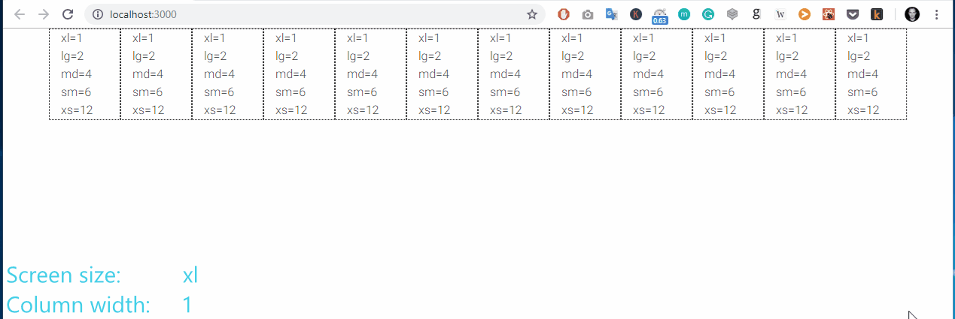
I hope that you now you can understand how easy it is to build responsive components using Bootstrap. Let's get back to our app. We want to create a two-column layout that will be visible on the desktop (extra large and large) as well as tablets in horizontal aspect (medium). For smaller screen size we want our columns to nest one below the other.

4. Responsive grid of our Calendar App
Replace the template of our App.vue file with following code:
- Vue (template)
<mdb-container>
<mdb-row>
<mdb-col col="9">Left column</mdb-col>
<mdb-col col="3">Right column</mdb-col>
</mdb-row>
</mdb-container>
COPY CODE
This will render the expected result. note that we have provided only a medium breaking point. Bootstrap by default assumes that we want 9/3 ratio not only for medium screen but also for bigger screens, as well as that we want everything which is lower than md to display on full 12 width.

1. Event component
Our app will consist of two components. The main one - the App component, which will be responsible for layout and the Event component - a sub-component which will render a single event entity.
- Create a new components folder under src/
- Create a new Event.vue file
- Paste the initial Event code
  - Vue
<template>
<div>
<h3>9:00 - Title</h3>
</div>
</template>

<script>
export default {
name: "Event"
};
</script>

<style scoped>
</style>
COPY CODE
Most of the people will simply call Event a component. This is perfectly fine, however, there is the one important thing that I want you to remember if you didn't have any experience with Object Oriented Programming in the past.
Our class is just a definition of the component. It describes how our component will look and behave but it doesn't create an instance of the component yet.
You can think of it like a stamp. A stamp itself is just a definition of a picture/image. In order to create a stamp imprint, you have to make some action. Furthermore - our single stamp (class) can create multiple copies (instances).


2. Import and render Event component
- Open theApp.vue file
- Import
  - Vue (script)
<script>
import { mdbContainer, mdbRow, mdbCol } from "mdbvue";
import Event from "@/components/Event";
export default {
name: "App",
components: {
mdbContainer,
mdbRow,
mdbCol,
Event
}
};
</script>
COPY CODE
- Render the component in the part
  - Vue (template)
<template>
<mdb-container>
<mdb-row>
<mdb-col col="9">
<Event/>
</mdb-col>
<mdb-col col="3">Right column</mdb-col>
</mdb-row>
</mdb-container>
</template>
COPY CODE
As we mentioned before, since our component is a definition, we can render multiple instances of the same component.
- Add the second instance of the in the left column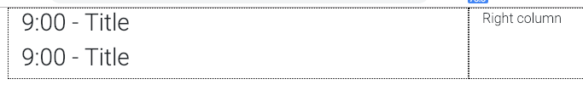
- Remove the text from the right column
  - Vue (template)
<template>
<mdb-container>
<mdb-row>
<mdb-col col="9">
<Event/>
<Event/>
</mdb-col>
<mdb-col col="3"></mdb-col>
</mdb-row>
</mdb-container>
</template>
COPY CODE
Now when we know how to create an instance of our component let's learn how to make it more dynamic and pass some data into it.
Earlier, we learned how to create the Event component. The problem is, that this component won’t be useful unless you can pass data to it, such as the time, title, location and description of the specific event we want to display. That's where props come into the picture.

Passing Data to Child Components with Props
Props are custom attributes that which we can register on a component. When a value is passed to a prop attribute, it becomes a property of that particular component instance. Let's define some props:
- Add , , and props to the part of an Event:
  - Vue (script)
export default {
name: "Event",
props: {
time: {
type: String
},
title: {
type: String
},
location: {
type: String
},
description: {
type: String
}
},
};
COPY CODE
Now when our props are defined we can update our template. To display props we will use the Mustache syntax (double curly braces)
- Update an template:
  - Vue (template)
<template>
<div>
<h3>{{time}} - {{title}}</h3>
<p>{{location}}</p>
<p>{{description}}</p>
</div>
</template>
COPY CODE
The last thing we have to do is to pass a value to the App component.
- Update the part:
  - Vue (template)
<template>
<mdb-container>
<mdb-row>
<mdb-col col="9">
<Event time="10:00" title="Breakfast with Simon" location="Lounge Caffe" description="Discuss Q3 targets"/>
<Event time="10:30" title="Daily Standup Meeting (recurring)" location="Warsaw Spire Office"/>
</mdb-col>
<mdb-col col="3"></mdb-col>
</mdb-row>
</mdb-container>
</template>
COPY CODE
Now we are able to dynamically generate unique instances of these events.
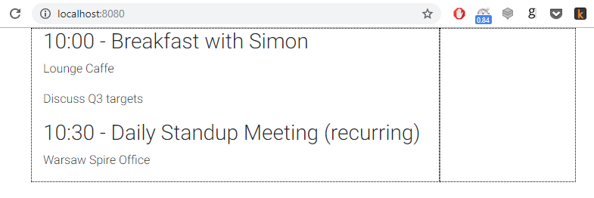

1. Initial events list
Since the component receives information like the date or title from the (parent) component, it is now the component which will be responsible for storing and managing lists of events. Let's add an initial list of the events into the App.vue script part inside of the function:
- Vue
<script>
import { mdbContainer, mdbRow, mdbCol } from "mdbvue";
import Event from "@/components/Event";
export default {
name: "App",
components: {
mdbContainer,
mdbRow,
mdbCol,
Event
},
data() {
return {
events: [
{
time: "10:00",
title: "Breakfast with Simon",
location: "Lounge Caffe",
description: "Discuss Q3 targets"
},
{
time: "10:30",
title: "Daily Standup Meeting (recurring)",
location: "Warsaw Spire Office"
},
{
time: "11:00",
title: "Call with HRs"
},
{
time: "12:00",
title: "Lunch with Timmoty",
location: "Canteen",
description: "Project evalutation"
}
]
};
},
};
</script>
COPY CODE
Now when we have our initial data, let's learn how to use for loop to dynamically generate all events from the array.

2. v-for

2.1 Dynamic loop
Let's replace our static code:
- Vue (template)
<Event time="10:00" title="Breakfast with Simon" location="Lounge Caffe" description="Discuss Q3 targets"/>
<Event time="10:30" title="Daily Standup Meeting (recurring)" location="Warsaw Spire Office"/>
COPY CODE
with a dynamic call:
- Vue (template)
<Event
v-for="event in events"
:time="event.time"
:title="event.title"
:location="event.location"
:description="event.description"
/>
COPY CODE
Which works like a charm:
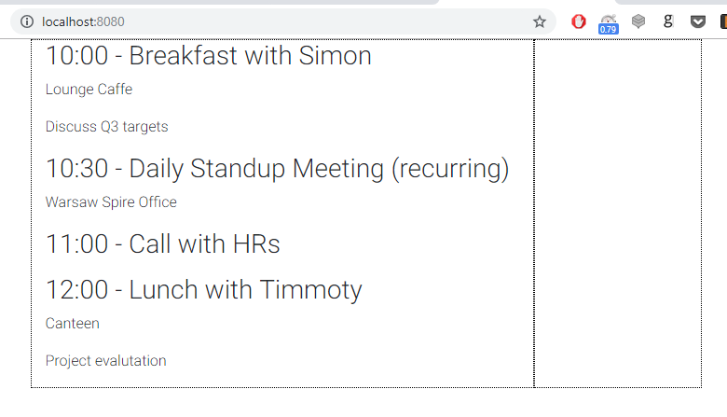
The is quite self-descriptive. It loops through each element within the array and creates an instance of each component.
In order to access attributes of a particular event we are defining its alias in the declaration:
event in events"
Now we can access it, i.e. its title calling .
The alias for a single element can have any name, we could use shorter version and call it :
- Vue
<Event
v-for="e in events"
:time="e.time"
:title="e.title"
:location="e.location"
:description="e.description"
/>
COPY CODE
However, it's a good practice to use a descriptive name to make your code easier to understand. As you also noticed within the loop we are mapping our element attributes i.e. (right side) to the time property (left side):
(Event component instance property) = (events[] array element)

2.2 Unique key
Everything works like a charm so far. At least in a browser. However, if we look into our console we will notice the following Warning:
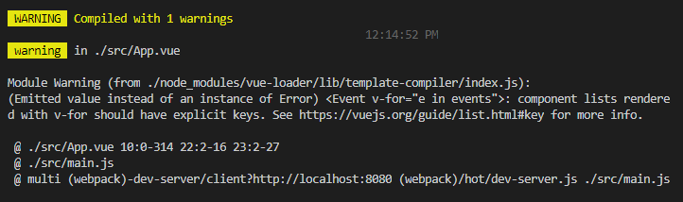
This warning tells us that each element should contain a unique key. This helps Vue to access each element. Let's quickly check why this is important.
With the help of a small Chrome extension - Vue.js devtools we can check the Virtual DOM of our application. This is how it looks now:
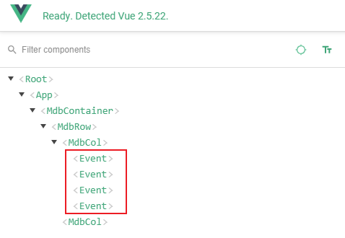
As you can see, all component instances look exactly the same. If we want to update a specific one it's difficult to access a particular one. We can quickly fix this. Let's update our loop:
- Vue (template)
<Event
v-for="(event, index) in events"
:index="index"
:time="event.time"
:title="event.title"
:location="event.location"
:description="event.description"
:key="index"
/>
COPY CODE
And check our code again using the same extension:
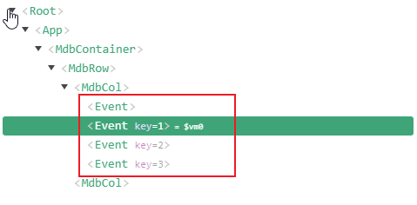
As you can see each Event has now a unique key (the first element has by default key=0, therefore it is not displayed).
Let's quickly review the new code. We added the second parameter (index) parameter to our loop:
index) in events"
This is an auto incremented index, which means it increases value with each iteration. We have bound it to the property which will help Vue to quickly access a specific item without needing to loop through all the elements within the array.
We also added an extra property and mapped it to the same value. This will help us within the application, to access a specific from the source code.
Since we have added mapping to a new property, the last step to do is to extend a list of properties in the Event.vue file. Let's add a new prop to the props list:
- Vue (script)
props: {
index: {
type: Number
},
time: {
type: String
},
title: {
type: String
},
location: {
type: String
},
description: {
type: String
}
},
COPY CODE
Since we know how to dynamically render from an array, let's give some shape to our app.

1. Style Event component
- Let's import Badges and Icons from the mdbvue library in Event.vue
  - Vue (script)
<script>
import { mdbBadge, mdbIcon } from "mdbvue";

export default {
name: "Event",
components: {
mdbBadge,
mdbIcon
},
props: {
index: {
type: Number
},
time: {
type: String
},
title: {
type: String
},
location: {
type: String
},
description: {
type: String
}
},
methods: {
onDelete() {
this.$emit('delete', this.index);
}
}
};
</script>
COPY CODE
We will use them within our template.
- Update the template with the following HTML code:
  - Vue (template)
<template>
<div>
<div class="media mt-1">
<h3 class="h3-responsive font-weight-bold mr-3 pt-0">{{time}}</h3>
<div class="media-body mb-3 mb-lg-3">
<mdb-badge tag="a" color="danger-color" class="ml-2 float-right">-</mdb-badge>
<h6 v-if="title" class="mt-0 font-weight-bold">{{title}}</h6>
<hr class="hr-bold my-2">

<p class="font-smaller mb-0">
<mdb-icon icon="location-arrow"/> {{location}}
</p>
</div>
</div>
<p class="p-2 mb-4 blue-grey lighten-5">{{description}}</p>
</div>
</template>
COPY CODE
Now our app starts looking better.
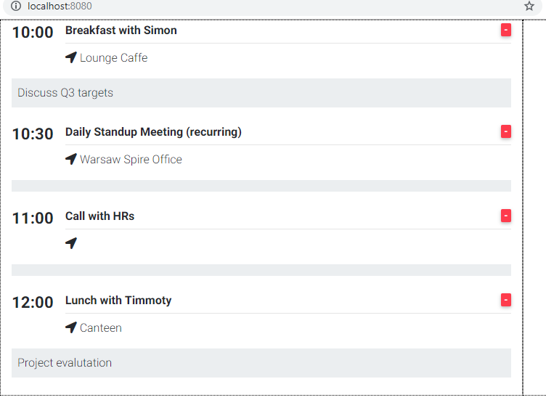
However, you probably noticed that some of the don't have a location nor description but we still display a placeholder for them. This doesn't look nice, so in order to fix it we will use another Vue directive -

2. v-if directive
One of the reasons why Vue has grown so fast recently is the fact that it comes with a variety of predefined directives like which you already know. In this lesson, we will learn how to use , and directives.
Let's have a look at our description paragraph:
- Vue
<p class="p-2 mb-4 blue-grey lighten-5">{{description}}</p>
COPY CODE
We can easily define whether we want to render an entier paragraph using a simple if condition:
- Vue
<p v-if="true">I am rendered!</p>
<p v-if="false">I am not :(</p>
COPY CODE
And below is an example of our description paragraph:
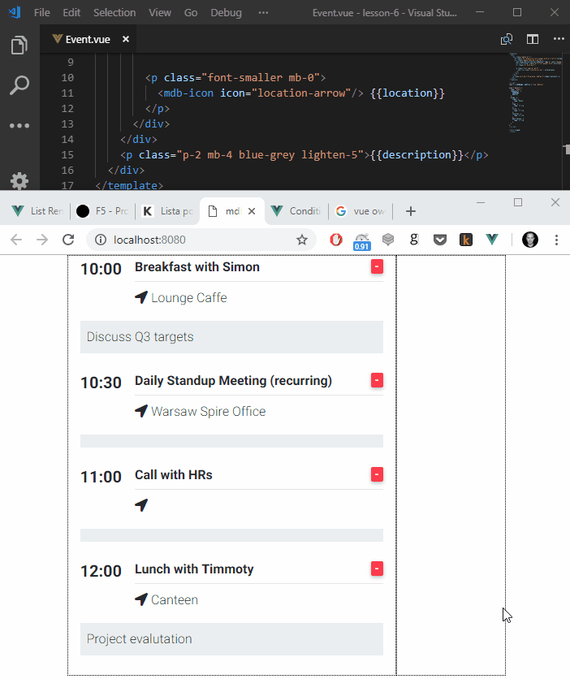
Of course we don't want to set it globally, instead we want to display the paragraph depending on whether a prop exists. In order to do that we can simply provide it as an argument to the function:
- Vue (template)
<p v-if="description" class="p-2 mb-4 blue-grey lighten-5">{{description}}</p>
COPY CODE
And use the same mechanism for
- Vue
<p v-if="location" class="font-smaller mb-0">
<mdb-icon icon="location-arrow"/> {{location}}
</p>
COPY CODE
Which solves our issue:
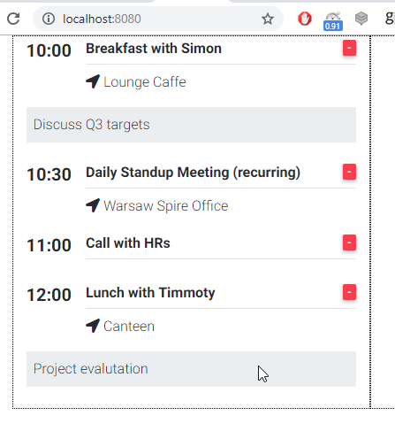
Note:
while using directive we don't use Mustache syntax, instead we directly provide the variable name in between double quotes ("").

3. v-else
Sometimes, instead of hiding empty elements you may wish to display some alternative content (i.e. if there is no image in your blog post, you may want to display a default one).
In Vue you can easily do this using the directive:
- Vue (template)
<template>
<div>
<p v-if="false">When v-if is true I am visible</p>
<p v-else>But when it's false, it's my airtime!</p>
</div>
</template>
COPY CODE
Preview:
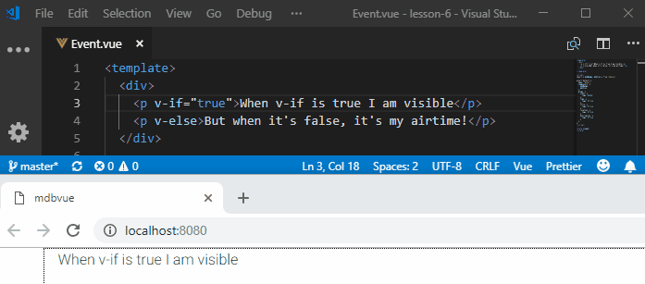

4. v-else-if
You may also end up in a situation where one "if" is not enough. I.e. imagine you have a list of authors and you want to render a different avatar for each author but still, if the authour is anonymous you want to display a default Avatar.
Again in Vue, you can very easily achieve that by using the directive:
- Vue (template)
<template>
<div>
<div v-if="true">A</div>
<div v-else-if="false">B</div>
<div v-else-if="false">C</div>
<div v-else>Not A/B/C</div>
</div>
</template>
COPY CODE
Preview:
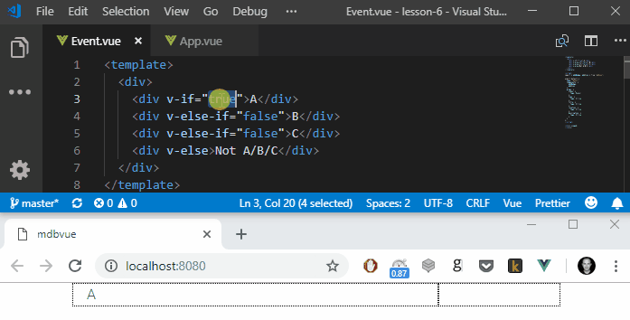
Exercise:
Check yourself - which value will be rendered if all conditions are set to true? You can submit your answer while rating this lesson. Please rate it using the stars below. When you vote, you will be able to leave the note where you can give extended feedback and provide the answer.
Your feedback is very important to us. Please help us in making our tutorials better.
Currently, our component displays an icon that is supposed to delete the item from the list. As you already know, the list of the Events is held in the parent component - . Therefore, it's not possible for the component to delete itself.
In order to delete an event from a list, we have to pass a call from the child component () to its parent component (). In this lesson, we will learn how to pass function calls between components.
Before we start to that, let's work on template first:

1. App template

1.1. Style
We don't need styles anymore, so let's remove them from both of the App.vue and Event.vue files.

1.2. Template
Let's update the template of our app:
- Vue
<template>
<mdb-container>
<mdb-row>
<mdb-col col="9">
<h2 class="text-uppercase my-3">Today:</h2>
<Event
v-for="(event, index) in events"
:index="index"
:time="event.time"
:title="event.title"
:location="event.location"
:description="event.description"
:key="index"
/>
<mdb-row>
<mdb-col xl="3" md="6" class="mx-auto text-center">
<mdb-btn color="info">Add Event</mdb-btn>
</mdb-col>
</mdb-row>
</mdb-col>
<mdb-col col="3">
<h3 class="text-uppercase my-3">Schedule</h3>
<h6 class="my-3">
It's going to be busy that today. You have
<b>{{events.length}} events</b> today.
</h6>
<h1 class="my-3">
<mdb-row>
<mdb-col col="3" class="text-center">
<mdb-icon far icon="sun"/>
</mdb-col>
<mdb-col col="9">Sunny</mdb-col>
</mdb-row>
<mdb-row>
<mdb-col col="3" class="text-center">
<mdb-icon icon="thermometer-three-quarters"/>
</mdb-col>
<mdb-col col="9">23°C</mdb-col>
</mdb-row>
</h1>
<p>
Don't forget your sunglasses. Today will dry and sunny, becoming
warm in the afternoon with temperatures of between 20 and 25
degrees.
</p>
</mdb-col>
</mdb-row>
</mdb-container>
</template>
COPY CODE

1.3. Script
Finally, let's import some missing components like and from the library:
- Vue (script)
import { mdbContainer, mdbRow, mdbCol, mdbIcon, mdbBtn, } from "mdbvue";
[...]
components: {
mdbContainer,
mdbRow,
mdbCol,
Event,
mdbIcon,
mdbBtn,
},
COPY CODE
Preview:
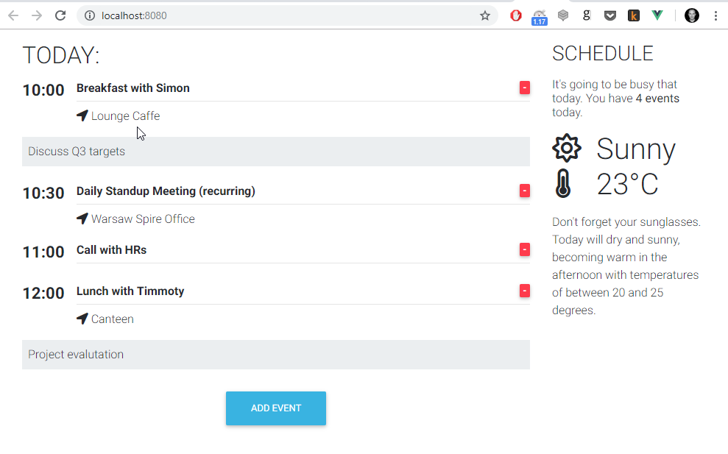
Note:
In the right-hand column, we added an Event counter which tells us how many events are scheduled for today. In order to get this number we are simply counting elements within the array using function.

2. Delete Event function
Now we can create a function which removes a particular from an array. It's a very simple function which accepts the id of the event which we want to delete, and remove it from the array[] using the function:
- Vue
handleDelete(eventIndex) {
this.events.splice(eventIndex, 1);
}
COPY CODE
In Vue we define new functions inside the within the function.
- Vue (script)
export default {
name: "App",
components: {
[...]
},
data() {
[...]
},
methods: {
handleDelete(eventIndex) {
this.events.splice(eventIndex, 1);
}
}
};
COPY CODE
Now when our function is ready, we can emit an event from the component.

3. Event emitting
Let's define an event handler for our component:
- Vue
methods: {
onDelete() {
this.$emit('delete', this.index);
}
}
COPY CODE
This function will emit an event with two parameters:
- name of the event - in our case
- payload - in our case it will be the id of the corresponding
Now we have to trigger it whenever users click on the delete icon. Let's therefore update our existing: tag.
- Vue
<mdb-badge tag="a" color="danger-color" class="ml-2 float-right">-</mdb-badge>
COPY CODE
with a function call.
- Vue
<mdb-badge @click.native="onDelete" tag="a" color="danger-color" class="ml-2 float-right">-</mdb-badge>
COPY CODE
Now whenever a user clicks on the delete icon, next to the title, it will emit a new event with the id of the clicked .

4. Catching & handling events
The last thing we have to do is to catch the emitted event in App.ve. In order to do that, let's update our invocation within template:
- Vue
<Event
v-for="(event, index) in events"
:index="index"
:time="event.time"
:title="event.title"
:location="event.location"
:description="event.description"
:key="index"
@delete="handleDelete"
/>
COPY CODE
As you noticed, we have added a handle and bound it to the function which created in step 2.
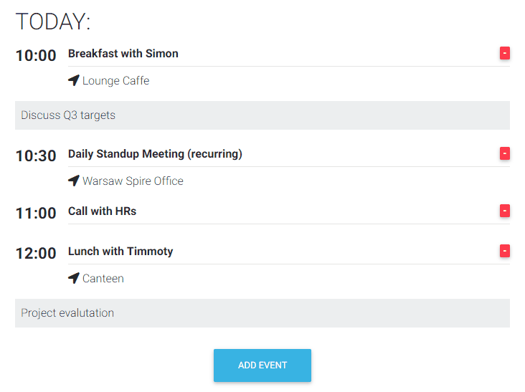
Now, whenever we click on a delete icon:
- User clicks on the delete icon
- calls the function
- emits an event
- The component catches it and triggers
- deletes the corresponding element from the array
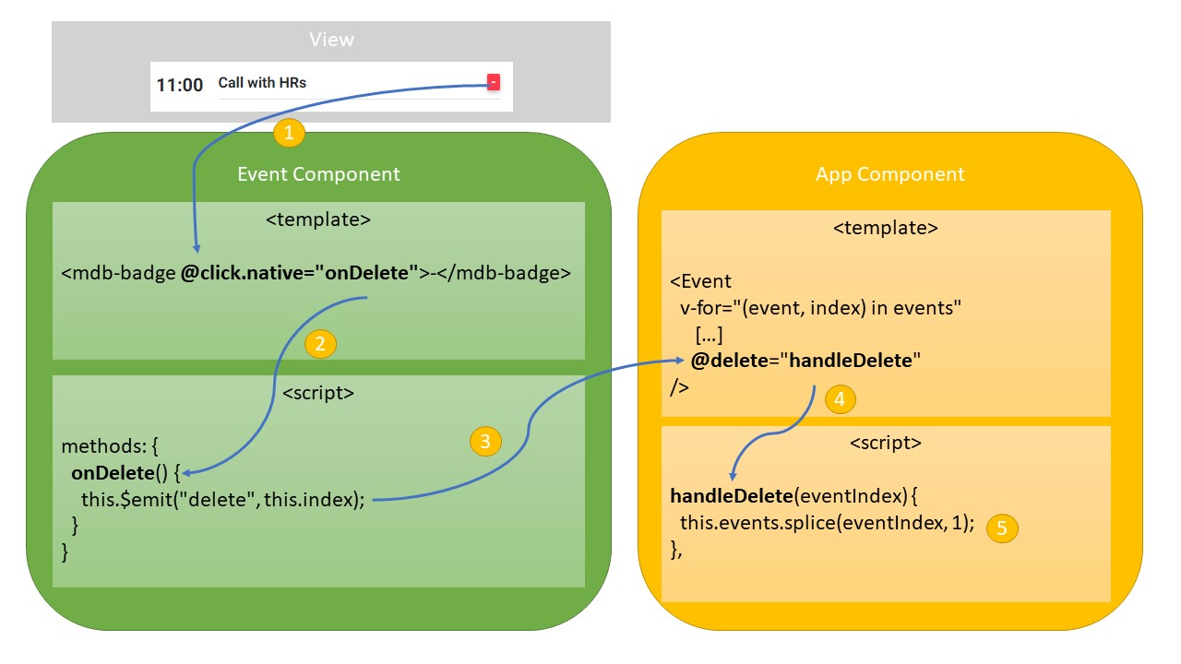
Finally, Vue automatically notices that the data model has changed and re-renders the list of events.
In this lesson, we will learn how to use modals in our projects.
Note:
Modals are small pop up windows which are really handy when you want to display to user extra content, configuration or consent request.
To use modals, follow the steps below.
- 1. Import the modal elements in App.vue
  - Vue (script)
import {
...
mdbModal,
mdbModalHeader,
mdbModalTitle,
mdbModalBody,
mdbModalFooter
} from "mdbvue";

[...]
export default {
name: "App",
components: {
...
mdbModal,
mdbModalHeader,
mdbModalTitle,
mdbModalBody,
mdbModalFooter,
...
},
COPY CODE
- Add the new variable within function:
  - Vue
data() {
return {
events: [
...
],
modal: false,
};
},
COPY CODE
- Add the modal body to the template before
  - Vue
<mdb-modal v-if="modal" @close="modal = false">
<mdb-modal-header>
<mdb-modal-title tag="h4" class="w-100 text-center font-weight-bold">Add new event</mdb-modal-title>
</mdb-modal-header>
<mdb-modal-body>Modal body</mdb-modal-body>
<mdb-modal-footer class="justify-content-center">
<mdb-btn color="info">Add</mdb-btn>
</mdb-modal-footer>
</mdb-modal>
COPY CODE
- Update the Add Event button to display modal on click (update value to true)
  - Vue
<mdb-btn color="info" @click.native="modal = true">Add Event</mdb-btn>
COPY CODE
The final content of the file will be:
  - Vue
<template>
<mdb-container>
<mdb-row>
<mdb-col col="9">
<h2 class="text-uppercase my-3">Today:</h2>
<Event
v-for="(event, index) in events"
:index="index"
:time="event.time"
:title="event.title"
:location="event.location"
:description="event.description"
:key="index"
@delete="handleDelete"
/>
<mdb-row>
<mdb-col xl="3" md="6" class="mx-auto text-center">
<mdb-btn color="info" @click.native="modal = true">Add Event</mdb-btn>
</mdb-col>
</mdb-row>
</mdb-col>
<mdb-col col="3">
<h3 class="text-uppercase my-3">Schedule</h3>
<h6 class="my-3">
It's going to be busy that today. You have
<b>{{events.length}} events</b> today.
</h6>
<h1 class="my-3">
<mdb-row>
<mdb-col col="3" class="text-center">
<mdb-icon far icon="sun"/>
</mdb-col>
<mdb-col col="9">Sunny</mdb-col>
</mdb-row>
<mdb-row>
<mdb-col col="3" class="text-center">
<mdb-icon icon="thermometer-three-quarters"/>
</mdb-col>
<mdb-col col="9">23°C</mdb-col>
</mdb-row>
</h1>
<p>
Don't forget your sunglasses. Today will dry and sunny, becoming
warm in the afternoon with temperatures of between 20 and 25
degrees.
</p>
</mdb-col>
</mdb-row>

<mdb-modal v-if="modal" @close="modal = false">
<mdb-modal-header>
<mdb-modal-title tag="h4" class="w-100 text-center font-weight-bold">Add new event</mdb-modal-title>
</mdb-modal-header>
<mdb-modal-body>Modal body</mdb-modal-body>
<mdb-modal-footer class="justify-content-center">
<mdb-btn color="info">Add</mdb-btn>
</mdb-modal-footer>
</mdb-modal>
</mdb-container>
</template>

<script>
import {
mdbContainer,
mdbRow,
mdbCol,
mdbIcon,
mdbBtn,
mdbModal,
mdbModalHeader,
mdbModalTitle,
mdbModalBody,
mdbModalFooter
} from "mdbvue";
import Event from "@/components/Event";
export default {
name: "App",
components: {
mdbContainer,
mdbRow,
mdbCol,
mdbIcon,
mdbBtn,
mdbModal,
mdbModalHeader,
mdbModalTitle,
mdbModalBody,
mdbModalFooter,
Event
},
data() {
return {
events: [
{
time: "10:00",
title: "Breakfast with Simon",
location: "Lounge Caffe",
description: "Discuss Q3 targets"
},
{
time: "10:30",
title: "Daily Standup Meeting (recurring)",
location: "Warsaw Spire Office"
},
{
time: "11:00",
title: "Call with HRs"
},
{
time: "12:00",
title: "Lunch with Timmoty",
location: "Canteen",
description: "Project evalutation "
}
],
modal: false
};
},
methods: {
handleDelete(eventIndex) {
this.events.splice(eventIndex, 1);
}
}
};
</script>

<style>
</style>
COPY CODE
- Save the file and run the app: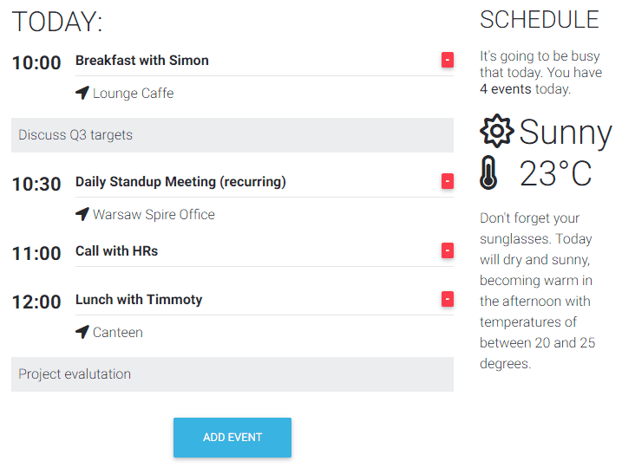
As you can see we can close that modal either by clicking on the X sign in the top right corner or by simply clicking anywhere outside the modal.
Note:
Modals are great tools and they can be customized in various ways. Most probably you will use them to get user consent for using cookies or to accept a privacy policy on a website, display a registration/login form or some extra details like map and/or contact form.
You can find dozens of predefined modal templates in our docs.
You may also wish to check out our modal generator.
In this lesson, we will learn how to deal with Inputs. Inputs are very widely used components in web development. We use them everywhere, starting with the login form, newsletter subscription forms, a new post editor through toconfiguration panels etc.
Just follow the steps below.
- Import and to App.vue
  - Vue (script)
import {
...
mdbInput,
mdbTextarea
} from "mdbvue";

[...]
export default {
name: "App",
components: {
...
mdbInput,
mdbTextarea,
...
},
COPY CODE
- Add a new array to
  - Vue (script)
data() {
return {
events: [
...
],
modal: false,
newValues: []
};
},
COPY CODE
- Replace the modal body with the following code
  - Vue
<mdb-modal-body>
<form class="mx-3 grey-text">
<mdb-input
name="time"
label="Time"
icon="clock"
placeholder="12:30"
type="text"
@input="handleInput($event, 'time')"
/>
<mdb-input
name="title"
label="Title"
icon="edit"
placeholder="Briefing"
type="text"
@input="handleInput($event, 'title')"
/>
<mdb-input
name="location"
label="Location (optional)"
icon="map"
type="text"
@input="handleInput($event, 'location')"
/>
<mdb-textarea
name="description"
label="Description (optional)"
icon="sticky-note"
@input="handleInput($event, 'description')"
/>
</form>
</mdb-modal-body>
COPY CODE
- Add the function
  - Vue
handleInput(val, type) {
this.newValues[type] = val;
console.log(this.newValues);
},
COPY CODE
Let's check how functions works. Let's print to console our state object every time this function is called. To do this, we add to the function body:
  - Vue
handleInput(val, type) {
this.newValues[type] = val;
console.log(this.newValues);
},
COPY CODE
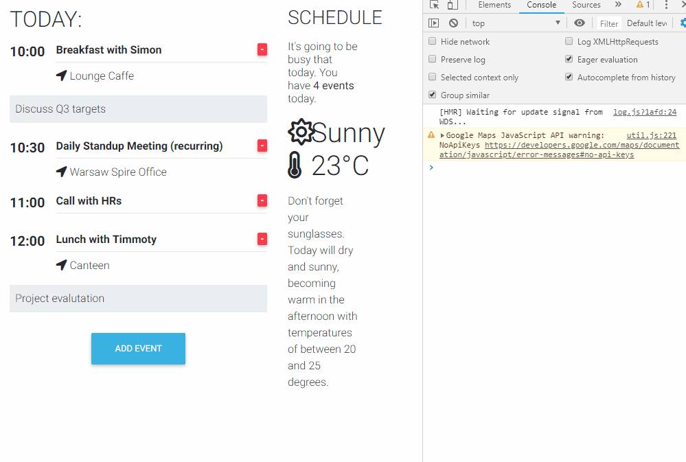
Every time we type something inside the input, it's value is added to the variable so we can use it when our form is submitted.
Since we have all of our inputs handled, let's remove console.log() and move to the final steps - to submit the form and add the new item to the list.
- Add the function:
  - Vue
addEvent() {
this.events.push({
time: this.newValues["time"],
title: this.newValues["title"],
location: this.newValues["location"],
description: this.newValues["description"]
});
}
COPY CODE
- Add to the Add button in modal footer:
  - Vue
<mdb-btn color="info" @click.native="addEvent">Add</mdb-btn>
COPY CODE
Now every time we click on the Add button, we will trigger the addEvent() function which will add a new item to the events array using push().
Note:
We don't have to add an id to the new event ourselves. Our loop will do that for us automatically.
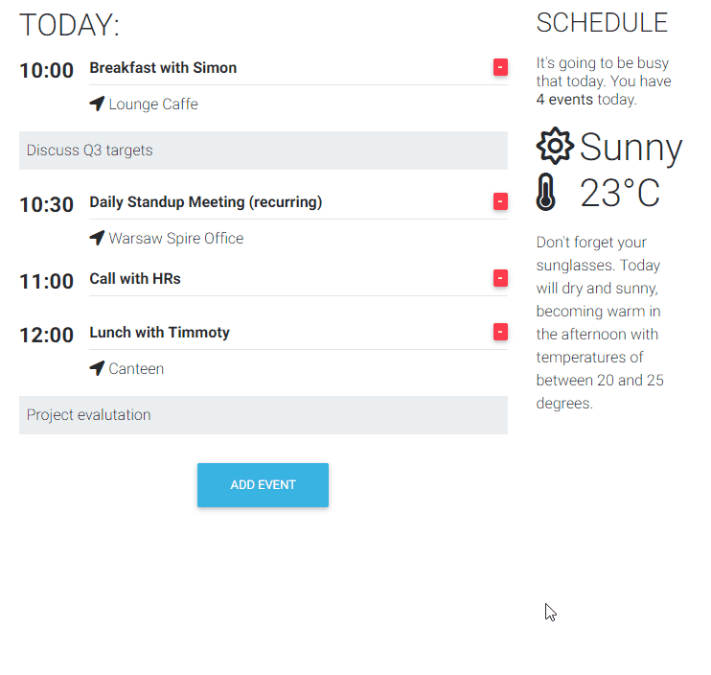

Summary
Our app is done, however there are still a few more things which we should do:
- change the type of any event properties (i.e. switch time to JS Date instead of string)
- call an external API to get a real weather forecast
- add validation to our form (make sure that the user fills in all of the mandatory data)
- handle duplicates
and a few more interesting things. We will learn all about that in Part 2 of our tutorial.
If you want to be notified as soon as second part of the tutorial will be released you can subscribe to our newsletter.
Important!
I am very happy that you reached this far. I would like to thank you and ask you for a small favor. If you didn't rate the previous lessons yet please either spend a few minutes and rate them or rate this lesson (as a summary of the entire tutorial) using the stars below.
Your feedback is very important to us! Once you vote (it's just a single click!) there will be optional form which let you leave comment to us. Please let us know what you liked and what you didn't like to help us make next tutorials better and better!

